**POWER BI ASSIGNMENT-10**

**Use Case –** Information about films

**Source –** List of films, ComfortBreaks

**Analytics –** To find average number of breaks for a film

Q1. It contain a table giving how many times the author would need to pop out for a comfort break during each film’s screening:

Step-1. The Dataset for this assignment is List of films.xlsx and ComfortBreaks.xlsx. The particular dataset has been loaded into the Powerbi application from Get data 🡪 Excel option

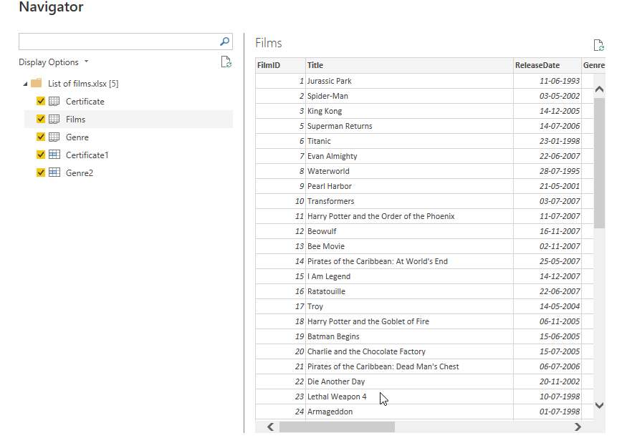

Q2. In the film table create a calculated column called NumberBreaks which shows for each film the number of breaks needed.

Step-2. To perform this task, a new column has been created under films table and the respective DAX formula is used and the screenshot is shown below

NumberBreaks = CALCULATE(VALUES(Sheet1[Breaks]),Sheet1[LowerLimit]<=EARLIER(Films[RunTimeMinutes]),Sheet1[UpperLimit]>EARLIER(Films[RunTimeMinutes]))

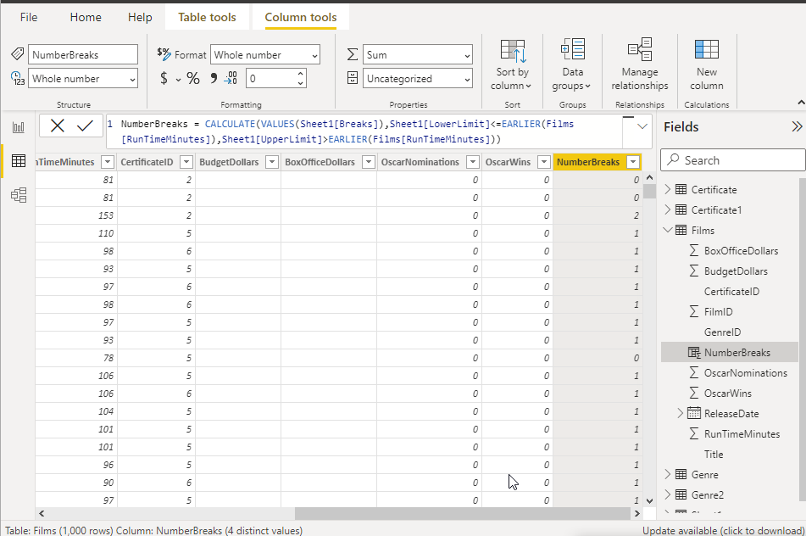

Q3. Try creating a second calculated column to do the same thing , but this time using the method you didn’t use the first time

Step-3. A switch statement has been used to implement the same concept and is shown below

NumberBreaks1 = SWITCH(TRUE(),Films[RunTimeMinutes]<90,0,Films[RunTimeMinutes]<150,1,Films[RunTimeMinutes]<210,2,Films[RunTimeMinutes]<300,3,4)

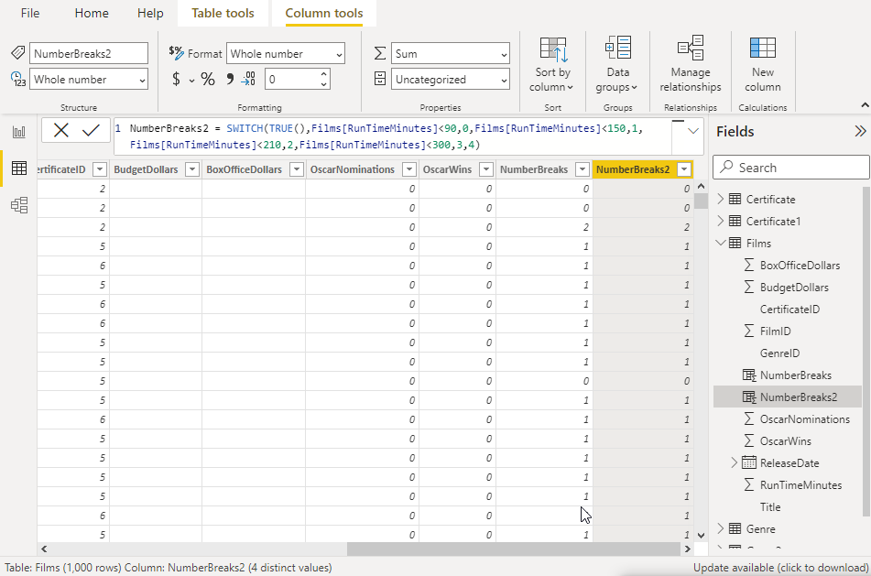

A table visual has been selected and dragged Oscar Wins and Number of Breaks into value field

